EXPT 9: Demonstrate simple linear regression algorithm for a regression problem
Aim: To implement simple linear regression algorithm for a regression problem
Requirement: Python IDE, sklearn
Procedure/Algorithm:
Data: Gather the dataset with one independent variable (X) and one dependent variable (Y).
Preprocess Data: Normalize or standardize the data if needed. Split the data into training and testing
sets.
Calculate Mean of X and Y: Compute the mean values of the independent variable (X) and dependent
variable (Y ):
Compute Slope (m) and Intercept (b)
o Compute the slope
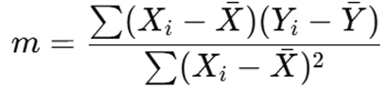
Compute the intercept (b):
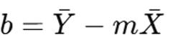
Formulate the Regression Equation:The regression equation is given as: Y=mX + b
Make Predictions: Use the equation to predict Y values for given X values.
Evaluate Model Performance:
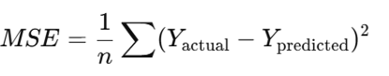

Compute R-Squared ( R² )
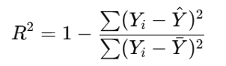

#CODE
from sklearn.linear_model import LinearRegression
import numpy as np
import matplotlib.pyplot as plt
# Input dataset
house_size = np.array([[6],[8] , [10], [12], [15], [18]])
house_price = np.array([25, 32, 40, 47, 60, 70])
# Create model
model = LinearRegression()
# Train the regression model
model.fit(house_size, house_price)
# Print model intercept and coefficient
print('Model Intercept (c):', model.intercept_)
print('Model Coefficient (m):', model.coef_[0])
# Predict House Price with test data
test_data = [[5], [11]]
result = model.predict(test_data)
print('Predicted response:\n', result)
# Predict House Price for a new sample
house_size_Sample = [[8.5]]
result = model. predict(house_size_Sample)
print('Predicted house_price:\n', result[0])
# Plot the actual data points
plt.scatter(house_size, house_price, color='blue', label='Actual Data', marker='o')
# Plot the regression line
plt.plot(house_size, house_price, color='red', label='Regression Line')
# Labels and title
plt.xlabel("house_size")
plt.ylabel("house_price")
plt.title("Linear Regression: house_size vs house_price")
plt.legend()
plt.show()

Output/Result:
Model Intercept (c): 1.8626465661641376
Model Coefficient (m): 3.80904523
Predicted response:
[20.9078727 43.76214405]
Predicted house_price:
34.2395309882747

